HISTORY OF MENTAL HEALTH SYSTEM IN MONTANA

1970s: Montana began deinstitutionalizing the mentally ill and intellectually developmentally disabled (IDD). Before the 1970s, the mentally ill and DD adults and children were treated in institutions across Montana. Warm Springs treated the mentally ill; Boulder campus treated the IDD population, and children were sent to Galen.

Mid-19702: Montana developed five Community Mental Health Centers and funded them to care for the mentally ill within the community: Western MT Mental Health Center, Eastern Montana Community Mental Health Center (Miles City), South Central Community Mental Health Center (Billings) and Center for Mental Health (Great Falls – now Many Rivers Whole Health). There was a fifth mental health center in Bozeman that closed and was absorbed by Western Montana Mental Health Center.

1980s to Present: The five centers were unable to handle all of the Medicaid patients in Montana, so other state-approved Medicaid providers opened in most of the major cities to treat patients. Some of these specialized in mental health, some in substance use disorder (SUD) and some in IDD services.

1997: In 1997, when the state adopted managed care to administer its mental health system, it tried to require private psychiatrists and therapists to be more accountable for the services they provided to poor patients. Instead of serving patients and then sending the state a bill, private providers were forced to get permission from the managed care company before treating the patient.

1999: Managed Care for Medicaid patients in Montana was ended by the Department of Public Health and Human Services in 1999 because so few providers were willing to take Medicaid patients.

2000 to Present: Montana returned to a fee-for-service (FFS) model which is currently only operated by five states across the U.S. In the FFS model, providers bill only for approved services and cannot bill for overhead services. At the same time, Federally Qualified Health Centers (FQHCs) are paid on a perspective payments system (PPS) that provides a larger bundled payment to cover the service and overhead, i.e., nursing care, case management, receptionist, pharmacy, etc.

For example, if you see a therapist at an FQHC (community health center like Riverstone), Medicaid will pay a PPS rate that covers all of the services that you receive and the cost of providing those services to you.

For Medicaid FFS providers will receive only the cost of the service they are providing, i.e., $92 for a 50-minute therapy appointment and nothing for the overhead of providing that care.

The Medicaid FFS rates have declined over the past 20 years and many providers have gone out of business unable to compete with hospitals or FQHCs.

For the past several decades, FQHCs have seen about 70% of the mentally ill and SUD patients. These patients have less severe illness and can be treated by their primary care doctor and a therapist. This is similar to having hypertension and having your primary care physician treat your hypertension. You will only need a referral to a specialist if your illness gets worse.

Thirty percent of the adults have a Serious Mental Illness (SMI). SMI is a small subset of the 300 mental illnesses listed in The Diagnostic and Statistical Manual of Mental Disorders (DSM). SMI includes disorders such as bipolar disorder, major depressive disorder, schizophrenia, and schizoaffective disorder.

Children with Severe Emotional Disturbance (SED) are persons who are under the age of 18, who have had a diagnosable mental, behavioral, or emotional disorder of sufficient duration to meet diagnostic criteria specified within DSM-V, that resulted in functional impairment which substantially interferes with or limits the child’s role or functioning in family, school or community activities.

SMI adults and SED children are primarily treated by the Medicaid state-approved agencies within Montana who are paid on the FFS system.

2017-2018: Shifting state revenues in 2017 and 2018 led to a series of budget changes in the 2019 biennium, due to action by both the Legislature and the governor. State agencies experienced cuts to their general fund budgets in the first year of the two-year budget period and planned for further cuts in the second year. However, agencies saw their funds restored in the second year of the biennium when the revenue situation improved. The budget cuts affected both the adult and children's mental health systems during Fiscal Year 2018, which began on July 1, 2017, and ended on June 30, 2018.

When the budget for the Department of Public Health and Human Services (DPHHS) was restored to its original appropriation for FY 2019, some but not all of the mental health cuts were reversed. FY 2019 began on July 1, 2018, and ended on June 30, 2019. The timeline below shows the key events behind the budget changes of that biennium.

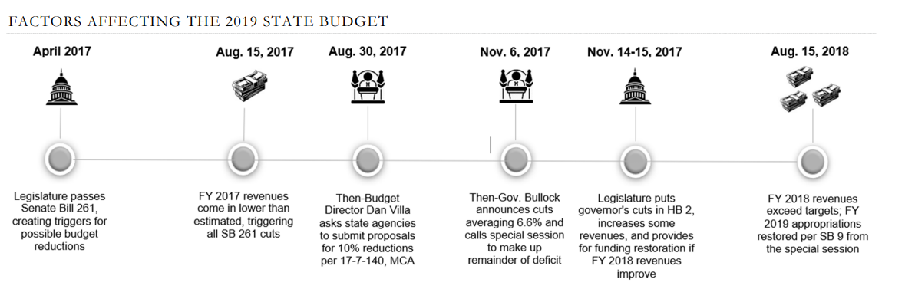

2020-2022: The COVID-19 worldwide pandemic came just as providers were beginning to negotiate new rates after the 2017-2018 budget cuts. Reimbursement for only a few services had successfully been increased, i.e., Targeted Case Management for Children, Intensive Outpatient for SUD, Home Support Services for children, etc.

As the pandemic caused a national shortage of providers, Medicaid providers lost even more clinicians who were able to work at a FQHC or hospital for considerably more money due to the higher reimbursement in the PPS model. At the same time, referrals for services increased dramatically due to the stressors brought about from the pandemic, i.e., lost jobs, skyrocketing housing and daycare costs, work and school from home requirements, anxiety created by the pandemic, and illness among kids and adults.

2021: In 2021, the Legislature appropriated $2.7M for a third-party, objective Medicaid rate study requested by the Governor and DPHHS. Guidehouse was hired for this rate study and over 9 months, providers provided detailed cost reports to Guidehouse to establish the costs of providing care by the Medicaid providers. Adult mental health, children’s mental health, substance use disorder, senior and long-term care providers, and developmentally disabled providers were studied in the first round. Benchmarks for these services were provided to the Legislature, Governor, and DPHHS in July 2022.

2023: The 2023 Legislature appropriated $330M to raise Medicaid rates for the studied providers to the benchmarks of costs provided by the rate study. The Governor signed this appropriation as part of HB2 and the rates will be finalized in September 2023 and will be paid retroactive to July 1, 2023.

However, inflation continues to increase, and the benchmark rates continue to lose ground to inflation and will need to be recalculated in the near future.

https://leg.mt.gov/content/Committees/Interim/2021-2022/Children-Families/Studies/SJR-14/nov2021-windecker-handout-mental-health-centers.pdf
https://scholarworks.umt.edu/cgi/viewcontent.cgi?article=9748&context=etd
https://smiadviser.org/about/serious-mental-illness
https://ccfhh.org/what-is-serious-emotional-disturbance-sed/
https://leg.mt.gov/content/Committees/Interim/2021-2022/Children-Families/Studies/SJR-14/sept2021-budget-cuts-restoration-summary.pdf
https://dphhs.mt.gov/assets/ProviderRateStudy/Reports/MTProviderRateStudyReport.pdf Mary Windecker Executive Director BHAM August 2023

